**Unit 6 Similarity Quiz *(20 points)***

1. *(2 points)*

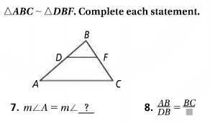

1. *(2 points)*   
   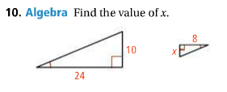



1. *(2 points)* Are the two triangles similar? Pick *Yes* or *No* and fill in the blanks.

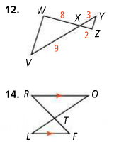

*Yes* ________________ ~ __________________ by ___________________________________________________

*No* because ___________________________________________________________________________________

_________________________________________________________________________________________________

1. *(2 points)* Are the two triangles similar? Pick *Yes* or *No* and fill in the blanks.



*Yes* ________________ ~ __________________ by ___________________________________________________

*No* because ___________________________________________________________________________________

1. 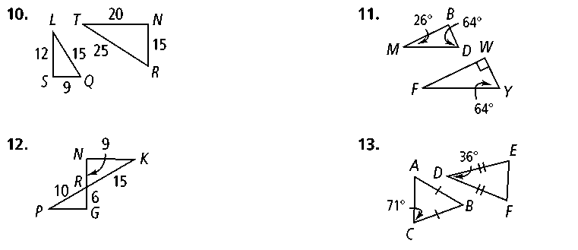Write a two-column proof for the following problem *(8 points)*  
   **Given: $NG intersects with PK at point R,$ $$NR=9, RK=15, PR=10, RG=6$$** **Prove: $ΔNRK\sim ΔGRP$**

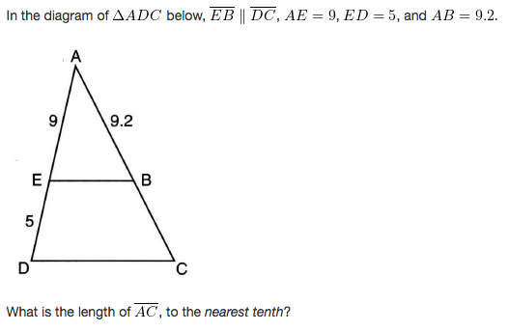

1. *(2 points)*

 

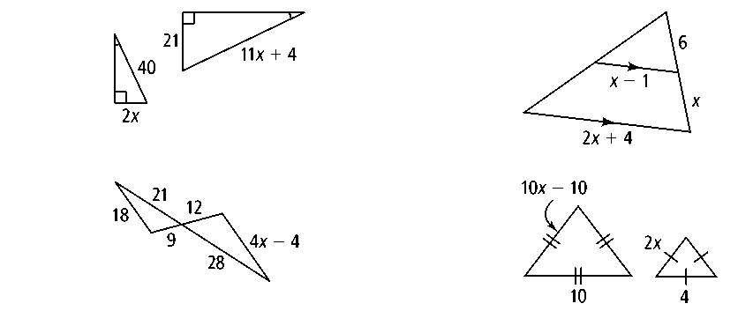

1. *(2 points)*

Solve for x.